How to subscribe the “Servizi Premium” from the Alumni Community
- Click the link -> https://alumni.unicatt.it/alumni-home-servizi-e-iniziative

- Scroll the page till you find the section “Servizi premium”
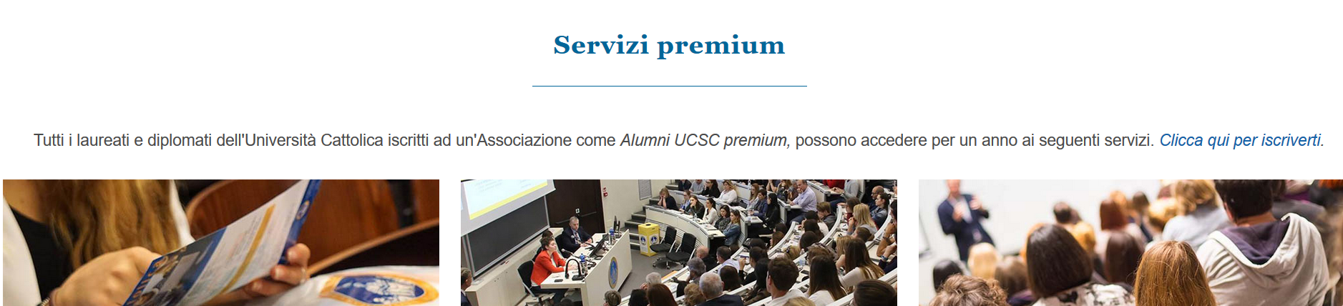

- Click “Clicca qui per iscriverti”
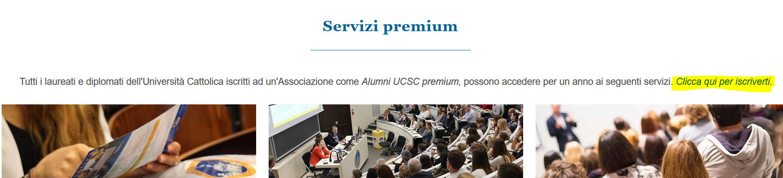

- Create a new account for the My Alumni personal page (or access with yours if you already have one)
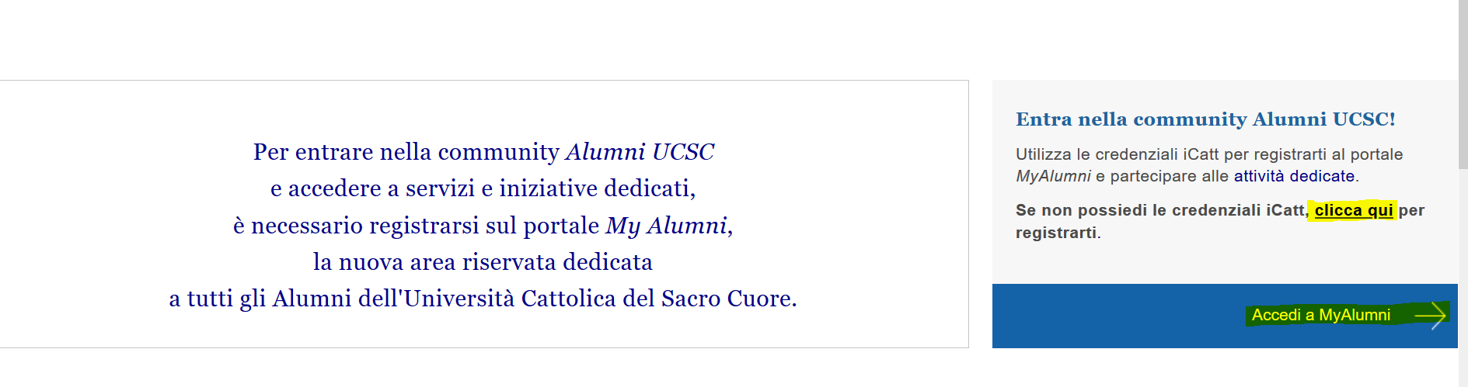

- Within your personal area you will find the possibility to subscribe the Alumni Premium, click it.
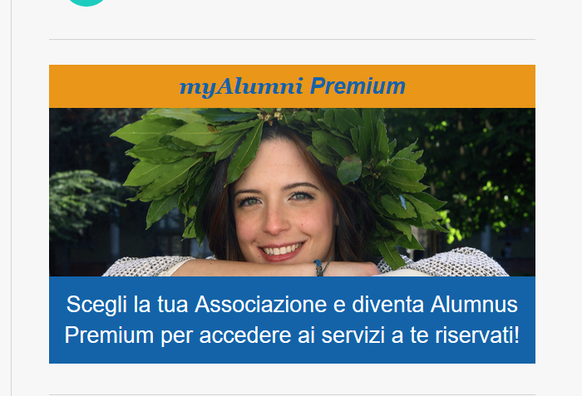
- Choose one of the Alumni associations:
- Associazione Necchi is the historical general Alumni UC Association, choose this one if you were an UC Alumnus who have never lived within the university's internal colleges / dormitories.
- Choose one of the others if you were living within one of these colleges / dormitories (Agostinianum, Marianum or S. Isidoro).

- 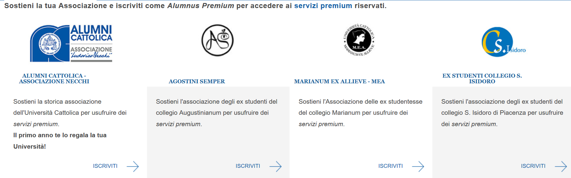

- Select the annual sum you prefer and pay

- With the payment recipt you will have access to the discount of 500 euro on the Master course

